**ETL Project Final Report**

**Team Members – Erik Lockwood, Maria Lara, Deepika Awasthi**

**Data source Description**

**Following data sources were used for this ETL project**

1. **CSV files from kaggle link**

<https://www.kaggle.com/stefanoleone992/imdb-extensive-dataset?select=IMDb+title_principals.csv>

* + **IMBD Movies.csv**
  + **IMBD Names.csv**
  + **IMBD Ratings.csv**

1. **CSV files from data world link**

<https://data.world/data-society/imdb-5000-movie-dataset/workspace/file?filename=movie_metadata.csv>

* + **movie_metadata.csv**

1. **CSV files from following link**

[https://www.kaggle.com/ruchi798/movies-on-netflix-prime-video-hulu-and-disney](https://slack-redir.net/link?url=https%3A%2F%2Fwww.kaggle.com%2Fruchi798%2Fmovies-on-netflix-prime-video-hulu-and-disney)

* + **MoviesOnStreamingPlatforms_updated.csv**

**Extract**

1. **Extracted all the below character details from IMBD Names.csv file**
   1. Name
   2. Birth Name
   3. Height
   4. Birth Date
   5. Death Date
   6. Primary Profession
2. **Extracted all the below Movie details from IMBD Movies.csv file**
   1. Movie Title
   2. Release Year
   3. Duration
   4. Budget
   5. Gross Income
3. **Extracted Movie Genre from IMBD Movies.csv file**
4. **Extracted following details from movie_metadata.csv file**
   1. Director Facebook Likes
   2. Actor Facebook Likes

* **Transform**

**Actor Table**

1. Created a data frame “actors_transformed” to get character details from **IMBD Names.csv** file
2. The primary profession has comma separated profession values so created “actorscleancsv” dataframe by applying a split function

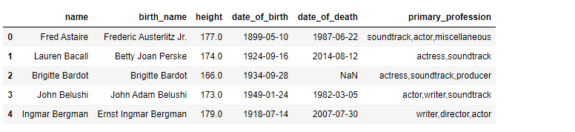

1. Renamed the column after the split back to Profession heading
2. Joined the “actors_transformed” dataframe with “actorscleancsv”
3. Filtered the data to get rows where profession is “actor” or “actress” and created a dataframe “actors_filtered”
4. Renamed the columns “date_of_birth” and “date_of_death” to “birth_date” and “death_date” to match the column name in database
5. Applied datetime formatting on “birth_date” and “death_date” columns
6. Extract Facebook Likes for the actor –
   1. Created dataframe “metadata_df” from **“movie_metadata.csv”**
   2. Grab “actor_name” and “actor facebook likes” column from the dataframe
   3. Rename the columns “actor_name” and “actor facebook likes”
   4. Perform a left join with “actors_clean” dataframe to merge the actor facebook likes and create a merged dataframe “actor_FB_merge”
7. Create a unique “actor_id” column in “actor_FB_merge” dataframe
8. Uploaded the final “actors_clean” dataframe to actor database table

**movie_actor table**

1. Created a data frame “movies_file” from **IMBD Movies.csv** file
2. Filter the dataframe “movies_file” for year > 2000
3. Retrieve columns “imdb_title_id “ , “title” and “ actors”
4. Actors value is comma separated so created “actormoviecleancsv” dataframe by applying a split function

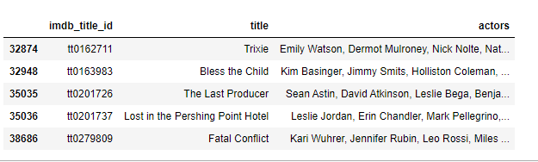

1. Renamed the column to “name”
2. Merged the actor details with “actormovie_renamed” to get actorid and actor facebook likes in 1 dataframe
3. Dropped the unnecessary columns not needed
4. Merged with movie dataframe to get movie ID for the actor ID combination
5. Loaded the “actormovie_final”dataframe to “movie_actor” table

**Country-Language Tables:**

Source: IMBD Movie Excel

1. Original excel was loaded as a Pandas Dataframe.
2. Data was filtered to get only movies and the rest of columns from 2000 to 2019.
3. Filtered DataFrame was cleaned to show only desirable columns.
4. Languages and Countries were columns with comma separated data, so “split” and “stack” pandas’ functions were needed to define a new row every time a cell contains more than one country or language separated by commas, as follow:

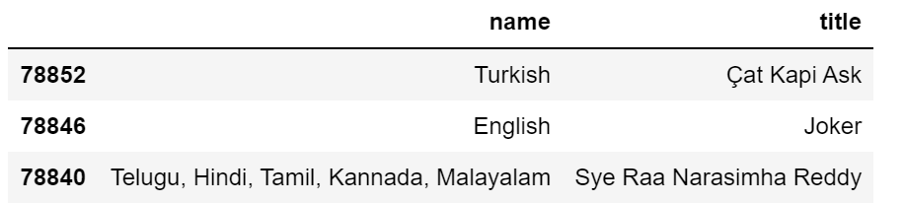

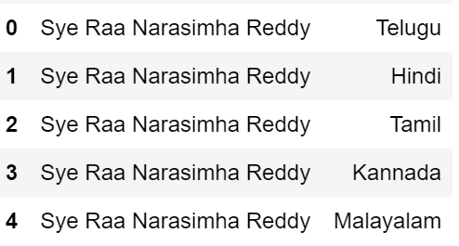

1. Columns renaming process to match same database columns names.
2. lang_id and country_id serial id’s generation.
3. Reorganizing columns order.

**“lang_movie” and “movie_country” Tables:**

Source: IMBD Movie Excel

1. Join each normalized languages and country tables (without comma separation) with the “Movie Table” that contains “movie_id”. Then columns were renamed.
2. A second Join between the above merged tables (countr_movie_merge, lang_movies_id_merge) with their corresponding country_table and language_table.

**Rating Table**

Source: IMBD Movie Excel (Excel), MoviesOnStreamingPlatforms_updated (CSV)

1. Original Movie as Dataframe (movie_table).
2. Filtered desirable columns
3. MoviesOnStreamingPlatforms_updated loaded as DataFrame (rating_source_df)
4. Columns renaming process.
5. Merge between rating_source_df and movie_table
6. Data cleaning of the merged dataframe (filetered and renamed columns)

**Director Table**

1. Created a data frame “actors_ directors_df” to get character details from **IMBD Names.csv** file
2. The primary profession has comma separated profession values so created “directors_merge” dataframe by applying a split function



1. Renamed the column after the split back to Profession heading
2. Filtered the data to get rows where profession is “director” created a dataframe “directors_filtered”
3. Created final “directors_clean” dataframe with only director names in it
4. Extract Facebook Likes for the director –
   1. Created dataframe “metadata_df” from **“movie_metadata.csv”**
   2. Grab “director_name” and “director_facebook_likes” column from the dataframe
   3. Rename the column “director_name”
   4. Perform a left join with “directors_clean” dataframe to merge the director facebook likes and create a merged dataframe “director_FB_merge”
5. Create a unique “director_id ” column in “director_FB_merge” dataframe
6. Uploaded the final “director_FB_merge” dataframe to director database table

**movie_drt table**

1. Created a data frame “movies_file” from **IMBD Movies.csv** file
2. Filter the dataframe “movies_file” for year > 2000
3. Retrieve columns “imdb_title_id “ , “title” and “ director”
4. Director value is comma separated so created “directormoviecleancsv” dataframe by applying a split function
5. Renamed the column to “name”
6. Merged the director details with “directormovie_renamed ” to get directorid and director facebook likes in 1 dataframe
7. Dropped the unnecessary columns not needed
8. Merged with movie dataframe to get movie ID for the director ID combination
9. Loaded the “directormovie_final” dataframe to "movie_drt" table

**Genre Table**

1. Created a data frame “movies_data_df” to get movie details from **IMBD Movies.csv** file
2. Filter the dataframe “movies_file” for year > 2000
3. Retrieve columns “imdb_title_id “and “ genre”
4. The genre has comma separated profession values so created “genrecleancsv” dataframe by applying a split function

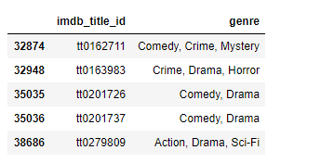

1. Renamed the column after the split back to name heading in “genre_df” dataframe
2. Create a unique “genre_id” column in “genre_df” dataframe
3. Uploaded the final “genre_df” dataframe to “Genre” database table

**movie_genre table**

1. Created a data frame “select_imdb_movies_df” from **movie_output** file
2. Filter the dataframe “movies_file” for year > 2000
3. Use the “genrecleancsv” which already have “imdb_title_id” and “Genre” values splitted
4. Merge the dataframe “select_imdb_movies_df” and “genrecleancsv” to get Movie id and “Genre” name together
5. Merge the result with “genre_df” dataframe to get “genre_id”
6. Drop the unnecessary columns
7. Loaded the “Movie_genre_final” dataframe to " movie_genre" table

* **Load**

A postgres relation database is used to load the tables. After visualizing and inspecting the data we found an entity relationship between various tables for the data we extracted. Hence decided to use postgres DB to load the data.

Please refer to ER diagram for all table and relationship details

1. Create a Postgress DB connection.
2. Used “to_sql” pandas method to load the data to tables